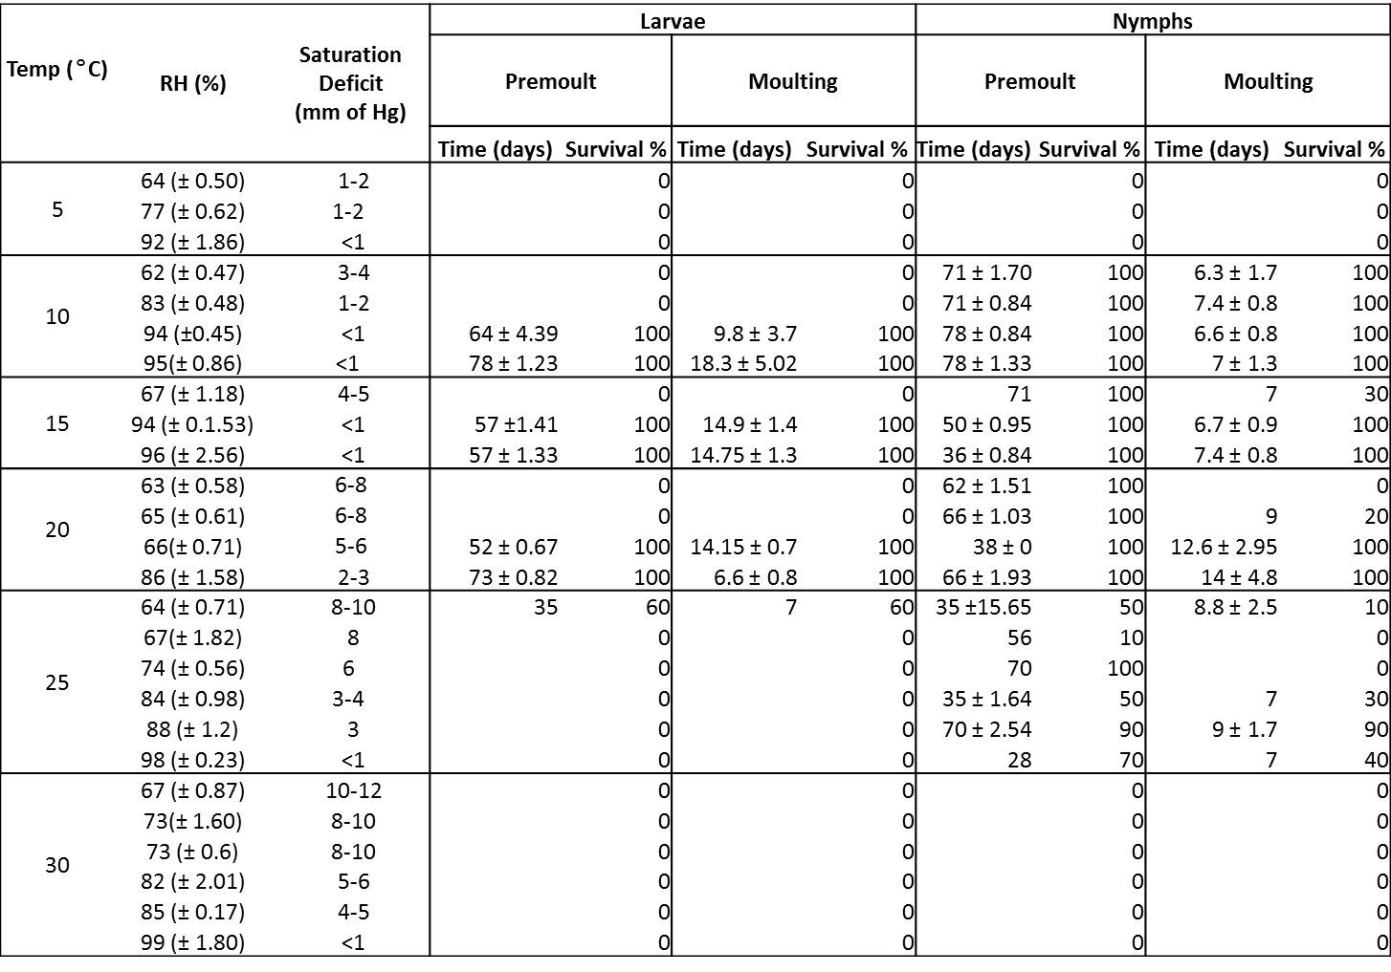
Table 1: Survival and development time of I. anatis engorged larvae and nymphs under tested laboratory conditions. Pre-moult in this table refers to the number of ticks that survived and started moulting and moulting refers to the actual time of moulting from attachment to complete emergence. Saturation deficit of air in each chamber was calculated using the formula from Randolph and Storey (1999).

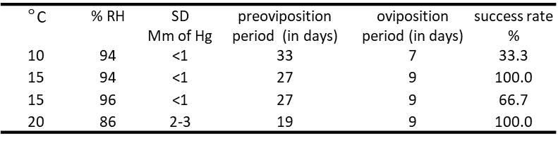
Table 2: The development times for the 12 female engorged ticks (three at each chamber) at given temperature and RH regimes.

